
Folding machines - Cas 38/52
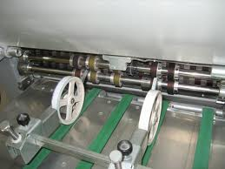
Technifold equipment requires stronger pressure springs on each side of the exit shafts.

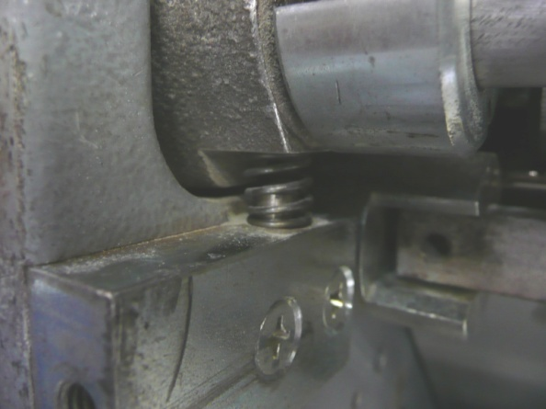
The 2 x original pressure springs are not strong enough for the crease and micro perforator to penetrate the paper.
Replace with the stronger springs and special washers included as standard in the pack.
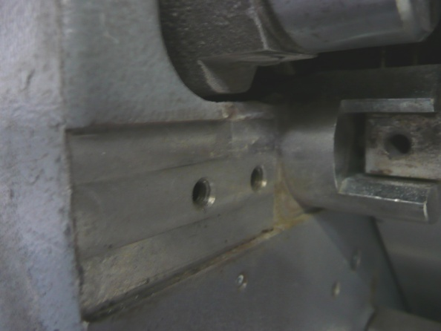
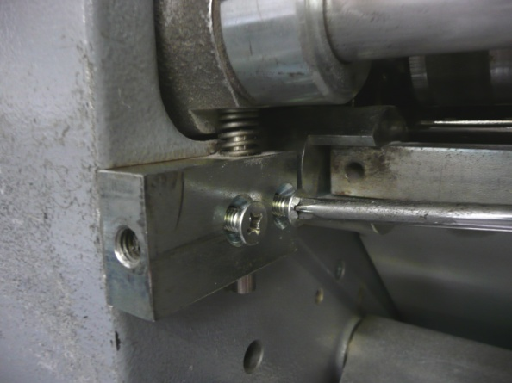

Unscrew the 2 threaded screws.

The spring housing sits in a recess.

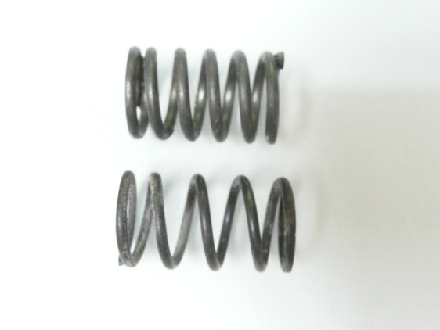
Stronger Technifold spring

Original spring

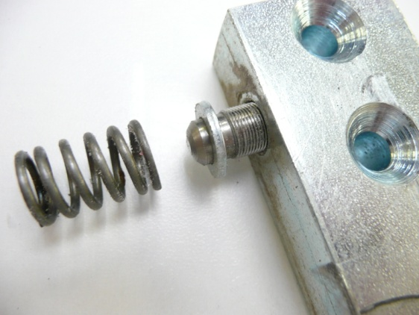
Important
The special washers are designed to sit on top of the screw threaded shaft pressure adjuster bolt.

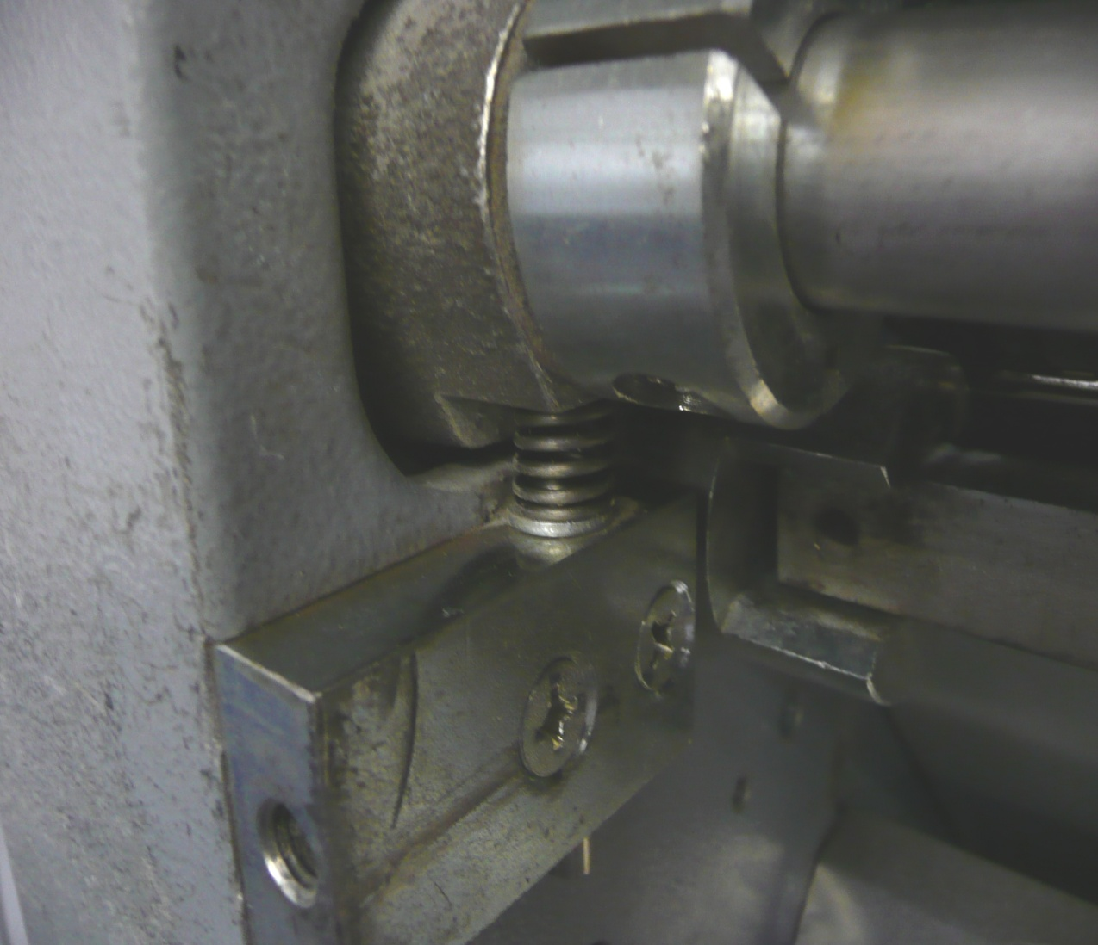
To get a good amount of pressure a gap of 1mm is required between the washer and the housing.
The pressure adjuster bolt should be tightened until there is a gap of approximately 1mm above the washer. This will give enough pressure to obtain a deep crease.

